Microgrids Formed by Renewable Energy Integration into Power Grids Pose Electrical Protection Challenges

**Zohaib Akhtar1 and Muhammad Asghar Saqib2**

1, 2Department of Electrical Engineering, University of Engineering and Technology, Lahore 54890, Pakistan

1zakhtar@uet.edu.pk, 2saqib@uet.edu.pk

**Highlights**

* The paper presents MATLAB model of a microgrid formed by renewable-energy sources.
* Different protection relays, used in a microgrid, are modelled in MATLAB/Simulink.
* Conventional protection techniques are analysed for microgrids’ application.
* Conventional protection schemes do not work correctly in a microgrid.
* A protection scheme has been designed that works satisfactorily in microgrids.

**Abstract** –*System parameters of a microgrid change in its two operating modes primarily due to output current limitation of PWM based inverters connected with renewable energy sources. The unavailability of an appropriate protection scheme, which must be compatible with both modes of a microgrid operation, is a major problem in the* implementation *of a microgrid. Two important properties of the microgrid components are peer-to-peer, and plug-and-play. It means that there is no component like a master controller which is critical for the operation of a system, and a distributed-generation unit can be installed at any location in a microgrid. These properties further complicate the protection of a microgrid.*

*This paper reports the MATLAB/SIMULINK model of a microgrid along with the models of the conventional protection schemes and renewable energy distributed-generation resources. Malfunctioning in the conventional protection schemes in islanding mode is identified and models of newly proposed protection schemes are developed. Different types of faults are simulated in all the protection zones of the system and the system parameters are analysed to identify the possible fault detection methods. Based on the simulation results, a protection scheme is recommended that can meet the protection standards such as selectivity, co-ordination and reliability.*

**Keywords:**Islanding-mode protection, microgrid, microgrid modeling, microgrid protection, relay models.

# **Introduction**

Increased awareness about the climate changes and the demand for green energy have caused mushrooming of renewable energy generation units in power systems. The demand for better system reliability requires the utilities to plug in these generation sources close to the loads [1]. One major problem with sources such as solar, wind turbines, fuel cells and micro-hydel turbines is their integration into an existing power grid, without major redesign of the system [2], [3]. An efficient method of resolving it is to integrate these units into a microgrid. This is the first step in the development of smart grids.

Microgrids are defined as medium- or low-voltage networks that have distributed generation sources together with local storage devices and loads (both critical and non-critical) [4]. Their total generation capacity varies between a few hundred kilowatts to a few megawatts. In normal operation a microgrid operates while remaining connected to a distribution network (grid connected mode), but in case of a grid fault, it is disconnected by a static switch (isolation or islanding mode). This ensures that supply to critical loads is not interrupted. Once the fault is cleared, the microgrid is resynchronized and reconnected with the utility grid.

In order to have all the microgrid functionalities without major system redesign and to have flexibility in the placement of new resources in a power system, a microgrid must have two main properties; peer-to-peer, and plug-and-play [5]. The peer-to-peer functionality demands that there are no components, like master controller or main communication hub, necessary for the operation of a microgrid. This ensures that the operation of a microgrid is not affected by the loss of any system component or generator. The plug-and-play functionally requires that a distribution generation (DG) unit can be placed at any point in a power system without the need of re-design of a protection scheme. This eliminates the chances of engineering errors and also gives a lot of flexibility in the installation of new units.

However, there are some challenges associated with incorporation of microgrids in a power system. The control and protection are major problems in the implementation of a microgrid [6]. In recent years a lot of work is being carried out on the control of microgrids. One area which needs more attention is the protection of a microgrid, especially when it is in islanding mode [7].

The key protection issue related with microgrids is that in islanding mode, the fault currents are much lower than those in the grid-connected mode [6]. This is mainly because of the output current limitation of most PWM converters which are required to interface renewable resources such as micro-turbines, photovoltaic cells, fuel cells, solar panels and wind turbines with a power system. Therefore, in the islanding mode, faults have to be cleared with techniques that do not rely on the detection of high fault currents.

A protection scheme is required to possess features such as selectivity, security and coordination. If selectivity is compromised, the reliability of critical loads in a microgrid is affected. The plug-and-play and peer-to-peer functionalities of a microgrid require that its protection schemes are adaptive, i.e. they should not rely on the location of the DG units, and there is no centralized protection device or master controller for the relays.

Some techniques have been proposed by researchers to detect the faults in a microgrid in islanding mode. It was proposed that the protection relay settings (fault current pickup values and operating times) can be modified by using communication signals on run time based on system operating states [8], [9], or based on the value of differential current at different buses [10]. However, by using these techniques, the plug-and-play functionality of a microgrid is compromised and there is an additional cost of communication between different protection relays. Differential current protection can be used to detect shunt faults [11]. The problem with this technique is that any relay downstream will not detect the fault current. Some other techniques make the use of optimal current pickup values between the load current and the fault currents [12], [13]. They can only work if the fault currents are higher than the peak load currents. With a high penetration of PWM inverters, this can not be assured.

Under-voltage detection can be utilized for the detection of L-G faults but the problem is that under voltages travel very rapidly in a microgrid due to its small area. Therefore, the under-voltage tripping will result in shutting down of the whole microgrid in case of a fault in any region. Thus, the property of selectivity is lost. Similarly, the problems arise while detecting line-to-line faults [7].

Negative sequence current detection can be a possible solution [14]. But in this case the protection device must be able to differentiate between negative-sequence currents caused by normal, abnormal and faulty system conditions. Some renewable generation units inject single-phase power into a microgrid, e.g. small photovoltaic systems. It further complicates the sequence currents based fault detection.

In this paper a microgrid is modeled in MATLAB/SIMULINK. The system is analysed to determine parameters such as currents, voltages, line impedances, and active and reactive powers, to develop protection algorithms. The proposed protection schemes by other researchers such as symmetrical-current protection [14], and time-graded voltage protection techniques [15] are also analysed. From this study a general protection scheme is recommended which should protect a microgrid under all fault conditions. The proposed protection scheme is secure and selective. It does not require any communication between the protection devices.

# **System Analysed**

The single-line diagram of a microgrid is shown in Fig. 1. A utility grid can consist of a large number of generating sources, transmission and distribution lines, transformers, and loads. The power level and hence the short-circuit currents of a utility grid are usually very high as compared to the power level of a microgrid. Feeders A, B and C form the microgrid. The microgrid is connected with the utility grid by a fast static switch. DG renewable sources are connected with feeders A, B and C. The total generation of these sources should be equal to the total load connected in the microgrid; otherwise non-critical loads are shut off in islanding mode.

A radial configuration is considered for the microgrid as MV (medium voltage) distribution networks are typically radial. Feeders B and C are a part of the same radial feeder to demonstrate the protection problems related to selectivity when two or more circuit breakers are installed on the same radial line. Feeder A is in parallel to the series combination of feeders B and C, while D represents the feeder parallel to the microgrid formed by feeders A, B and C. These parallel feeders allow us to simulate different fault conditions and to analyse the effects of various faults on protection scheme features such as selectivity, security and coordination. Similar systems have been used for the study of microgrid protection schemes in references [6], [8], [9], and [11].The details of the system parameters, chosen for the simulations, are given in Section III.1.

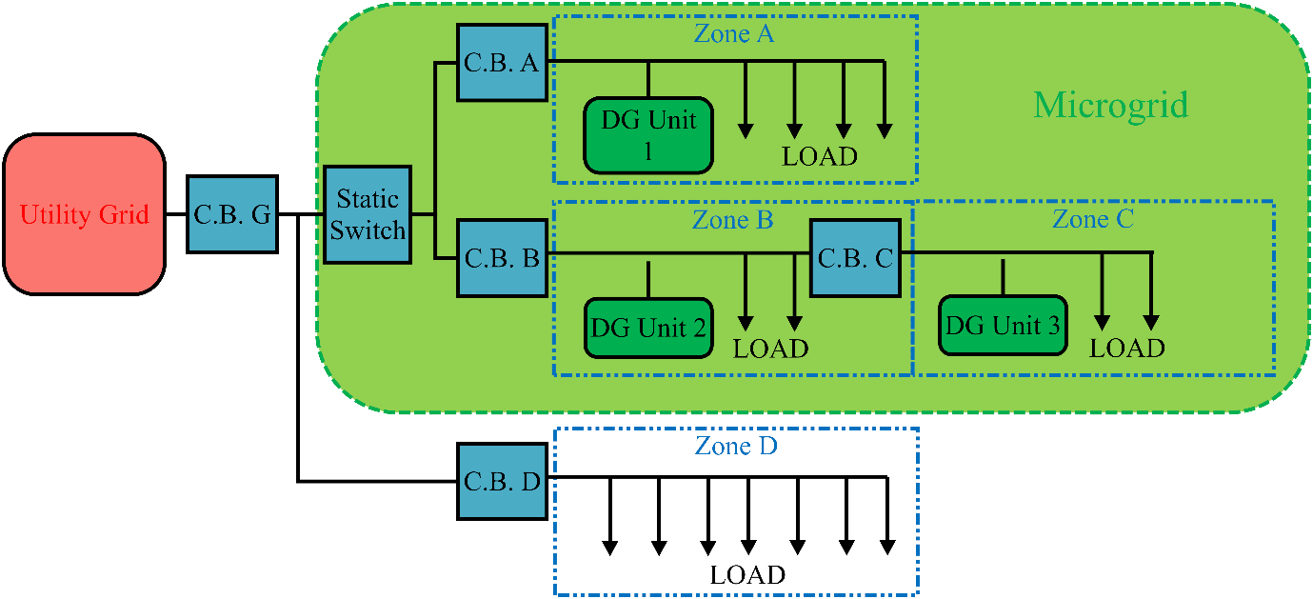

Fig. 1. Single-line diagram of a microgrid.

In case of a fault in the grid, the static switch must operate very quickly to isolate the microgrid. The operation is kept very fast to ensure that the low voltages produced during the fault do not affect the loads in the microgrid. The SEMI F47 standard, enlisting specifications for various fault types and their locations, does not permit voltages below 50% even with durations as short as 0.05 s (3 cycles at 60 Hz). If a utility feeder fault causes the voltage to drop below 50%, the faulty section must be separated as quickly as possible. The static switch must be a power electronic switching device and it can have a switching time in the range of a few milliseconds. The fault-sensing circuit might take 15-20 ms for the fault detection. When the fault is cleared, the static switch is reclosed. The microgrid is resynchronized with the grid before closing the static switch. Similar operation of the static switch is needed for a fault on parallel feeder D. The grid circuit breaker G acts as a back-up protection for the faults in zone D. The grid circuit breaker, thus, has a time delay to allow the operation of circuit breaker D.

In case of a fault in the microgrid the static switch should be opened to isolate the utility grid from the microgrid. There are two main reasons for that:

* The utility grid can have a very large short circuit current which can damage the microgrid if it is allowed to flow even for a very small time. There are certain circuit breakers in the microgrid which are operated with some time delay in order to ensure selectivity e.g. circuit breaker of zone B is time delayed to ensure it operates after circuit breaker of zone C. This time delay might result in breach of the thermal capacity of the components of the microgrid.
* The microgrid’s circuit breakers might not have the short circuit MVAs large enough to interrupt the circuits when the utility grid is feeding the fault. Once utility grid is isolated, the fault current will be only due to the PWM based renewable sources which can easily be interrupted by the microgrid breakers. This results in the selection of smaller and more economical circuit breakers within a microgrid.

This operating scheme can be achieved by keeping the operating time of static switch minimum. If the microgrid is in the grid-connected mode and there is a fault in it, the static switch will isolate the microgrid. The microgrid circuit breakers will be operated after some time delay which is determined by the selectivity scheme used. Once the faulty section of the microgrid is isolated by the operation of the circuit breaker of the respective zone, the rest of the microgrid is reconnected with the utility grid. This scheme has an added advantage; it keeps the operating scheme of the static switch very simple. It can be made to operate very quickly for any type of fault irrespective of the fact that the fault is in the utility grid or the microgrid. We will not require any directional protection. If there is a fault anywhere in the system, the static switch will be operated quickly.

In case of a fault in Zone A, initially the static switch will open. The microgrid will move into the islanding mode. At the second stage, the breaker of zone A will be opened after which the rest of the microgrid will be resynchronized with the system.

The microgrid always moves into islanding mode if there is a fault in the microgrid, because the static switch will operate faster than any other circuit breaker in the microgrid. After operation of the zone circuit breaker, the static switch should reclose. The DG units in the faulty zone should also be disconnected. The other circuit breakers should remain closed so that the supply is interrupted only for loads in the faulty zone. If the DG units in the other zones are not capable of meeting local load demands, non-critical loads are shut off. If the microgrid is in islanding mode initially, a fault in the microgrid will cause fault currents comparable to the normal load currents. In case of a fault on the line between the static switch and zone circuit breaker, the static switch and zone circuit breakers should open. There must be relay co-ordination between relays of zone B and C as they are on the same radial line.

# **SIMULINK Model**

In order to analyse the problems associated with the protection of microgrids, an accurate model of a microgrid is developed in MATLAB/SIMULINK. A brief description of the model used for this study is given in this section. It can be classified into three components; MV distribution system with microgrid model, protection scheme model and renewable DG unit model.

* 1. *MV Distribution System with Microgrid Model*

The system voltage is taken to be 11 kV, which is the standard medium voltage level in Pakistan. The grid is represented by a three-phase power source having a large power of 500 MVA. The distribution lines are chosen from the standard ACSR conductor table based on the loading conditions in the section where a line is to be installed. ACSR “Sparrow” conductor is chosen for feeders A, B and C. It has a maximum current capacity of 184 A under standard controlled conditions. ACSR “Plover” conductor is chosen for feeder D and grid distribution lines. It has a maximum current capacity of 1275 A under standard controlled conditions. All the distribution lines are represented by pi model, considering a balanced three-phase system. The impedance of the distribution lines is chosen by the standard table.

Feeders A, B and C form the microgrid. A model of PWM inverter based renewable resource is developed and it is connected to feeders A, B and C. All DG sources have a maximum power output of 220 kVA. The load on these three feeders is taken to be 200 kVA each. A three-phase load block is used to model the load.

Feeder D, which is the parallel feeder for the microgrid, represents all the parallel feeders. The load on feeder D is kept high (equal to 20 MVA) to represent all the parallel loads. Breaker SS represents the static switch. The operation of a static switch must be very fast so that the under voltages produced by an external fault do not affect the loads present in the microgrid. There is a synchronism relay connected to the switch SS, which checks the synchronism before the microgrid is connected back with the main grid after the fault is removed.

* 1. *Protection-Module Model*

The purpose of the protection module is to generate a trip signal in case of a fault in the system. It acts like a multifunction relay. The model of protection module was developed in SIMULINK by using basic block sets. The block diagram of the protection module is shown in Fig. 2. The main inputs to the protection module are phase current signal, neutral current signal and phase voltage signal.

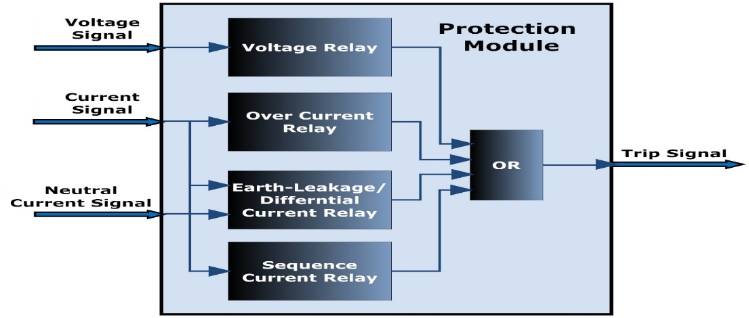

Fig. 2. Block diagram of the protection module.

In this study a definite time over current (DTOC) relay is used. If the value of current reaches the pick-up value, the relay waits for a definite time equal to the time setting of the relay: if the fault is not cleared during this interval, a trip signal is generated. The time delay is introduced to have a co-ordination between relays to possess selectivity of operation.

The block diagram of a DTOC relay model is shown in Fig. 3. The input to the relay is a current signal which comes from a current-measuring device. The RMS value of the current is calculated and it is sent to the comparison unit for comparing it with the pick-up value. If this value is higher than the pick-up value, a timer is activated and the comparison result is sent to the trip-generation unit. When the time reaches a value of time equal to the time-delay setting and if the result of comparison is still positive, a trip signal is generated. If the value of current becomes smaller than the pick-up value before the time delay is elapsed, the timer is reset.

In earth-leakage or differential-current relay, the value of the phasor sum of input current is compared with the current flowing in the neutral. Under normal conditions, these two currents will be equal in magnitude and opposite in direction so their vector sum will be equal to zero. In case of a ground fault, the vector sum of all the phase currents will not be equal and opposite of the current in the neutral. This condition can be used to indicate an earth fault. The block diagram of a differential-relay model is shown in Fig. 4. It also has a co-ordination time setting similar to that in a DTOC relay.

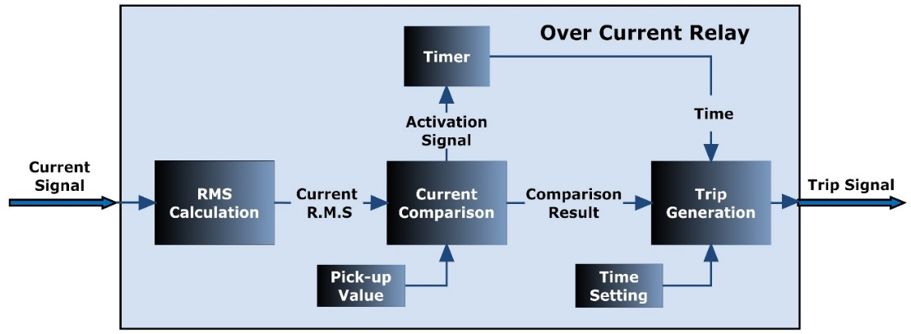

Fig. 3. Block diagram of DTOC-relay model.

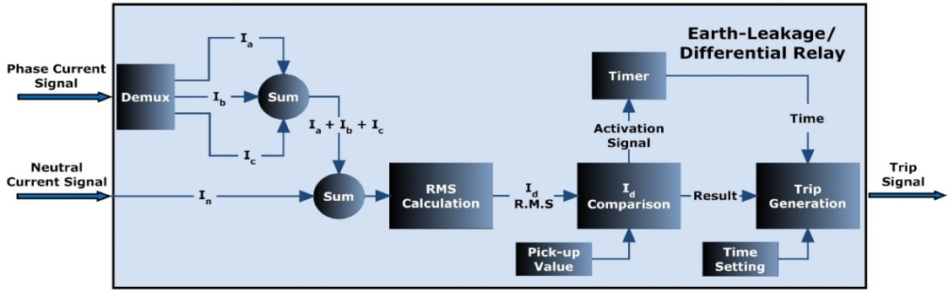

Fig. 4. Block diagram of the earth-leakage/differential-relay model.

A voltage relay generates the trip signal if the value of voltage is higher or lower than the maximum or minimum allowed system voltage respectively, for a time equal to or greater than the time allowed for voltage swells and sags. The block diagram of a voltage-relay model is shown in Fig. 5. The RMS value of voltage is calculated. If it is higher than the over-voltage setting or lower than the under-voltage setting of the relay, the timer is activated. If the timer runs for a time equal to the time-delay setting of the relay, a trip signal is generated.

In a sequence relay the current is first analysed to find out the negative, positive and zero sequence components. These current components are compared with the maximum allowed values to detect the presence of a fault. A time delay is introduced to allow the relay co-ordination. The block diagram of sequence-current relay is shown in Fig. 6.

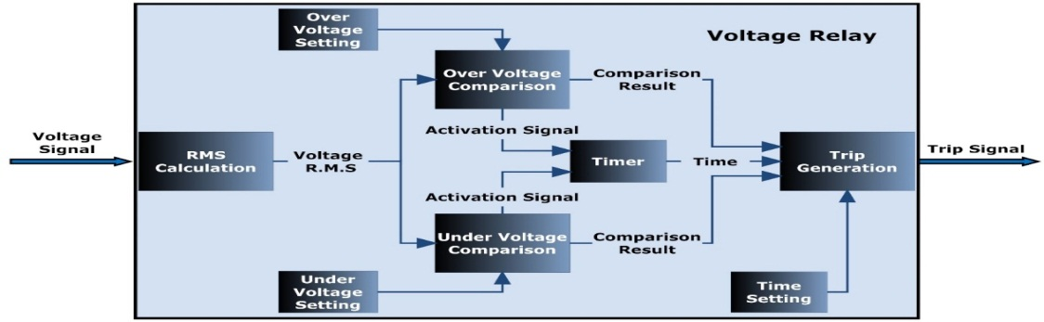

Fig. 5. Block diagram of the voltage-relay model.

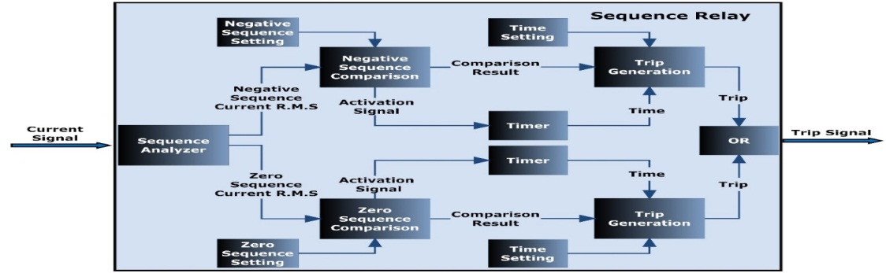

Fig. 6. Block diagram of the sequence current relay.

* 1. *Model of a PWM Inverter Based DG Unit*

Many renewable-energy sources produce a DC voltage, or a variable frequency AC voltage that needs to be rectified first. These DG units have PWM based inverters to connect the respective energy source to a power grid. The voltage level of the renewable energy resources is also not constant as it depends upon some natural resources which are not constant in nature. A PWM based voltage controlled inverter is used to invert this variable DC voltage into a constant magnitude and constant frequency AC voltage which can be directly connected to the power grid by using a step-up transformer. In this model, a fuel cell stack is used as a renewable resource but the results will hold for any renewable energy source which produces a DC voltage or a variable frequency/magnitude AC voltage, as in all these cases a voltage controlled inverter is needed for the grid connection. The built-in model of a fuel cell in SIMULINK is used. It contains one thousand fuel cells. The over-all system is capable of providing a power of 220 kVA to the utility grid. The output of the fuel cell is passed through a simple LC filter to reduce the ripples. This DC voltage is connected with a three-phase IGBT bridge inverter. The inverter is modeled by using basic circuit components. The PWM signal connected to the inverter-gate input is applied by a PWM generator which is controlled by a voltage-feedback mechanism. A unit cycle delay is introduced between the PWM generator and the inverter by a delay block. This delay is introduced to avoid malfunctioning during the start-up phase.

# **Analysis of Protection Schemes**

The system is simulated for normal operation in both the grid-connected and islanding modes, and normal load currents are calculated. The system is, then, simulated for different types of faults in all the protection zones, and the resulting currents and voltages are analysed to identify the possible protection parameters. The relay settings are decided on the basis of normal load and the fault currents. Different simulation cases are summarized below:

* 1. *Case 1: Grid Connected Mode with Standard Protection (Over Current)*

The system is simulated in grid connected mode with standard over-current protection. Load currents, fault currents, relay pick-up values and relay time settings at all system buses for both the grid connected and islanding modes are given in Table I.

There is a large difference between the normal load current and the fault current. The over-current protection will be very secure and reliable. Relay co-ordination, selectivity and back-up protection is achieved by introducing time delay (time setting) for the “up-stream” relays.

* 1. *Case 2: Islanding Mode with Standard Protection (Over Current)*

The fault current is very close to the normal rated line current so standard over-current protection will not work. The fault currents for a 3-phase fault at bus A are shown in Fig. 7. The fault is introduced after 0.04 seconds. Although initial current has a peak to peak magnitude of around 170 A and flows for half a cycle but it dies out very quickly and when the DC component vanishes a steady state current of nearly 2 pu is flowing in the system which is insufficient to cause a relay trip operation.

* 1. *Case 3: Islanding Mode with Earth-Leakage / Differential Protection*

Limited protection can be achieved in a microgrid if an over-current scheme based on differential current is adopted [11]. Non-zero value of the differential current will indicate earth leakage and possibly an earth fault. An important consideration is that we have to allow a little tolerance to avoid false trips that can occur if the relay is set to operate at zero value. Some leakage currents are always present in a system, and they must not trigger the protection relay.

It seems that differential protection can protect the islanding microgrid, but actually it can only provide limited protection. The differential currents were analysed for different types of faults such as L-G, L-L-G, L-L and L-L-L / L-L-L-G on all the zones. The results obtained for zone B are discussed here.

When there is a L-G fault in zone B, the differential current starts flowing. The currents flowing in the three phases and the differential currents at bus bar B and C are shown in Fig. 8. A fault is introduced at t = 0.02 seconds on phase a. Under normal conditions the value of differential current is nearly equal to zero, so the relay can be set to a very low pick up value. One big problem in this technique is that any relay downstream (relay connected to bus C) will not detect the differential current and the downstream source will continue to feed the fault. This is due to the fact that any relay attached downstream will have no differential current as the vector sum of phase and neutral currents will still be equal to zero. In the circuit under consideration, the differential current seen at bus bar C must be equal to zero, but as shown in Fig. 8, a very small magnitude (less than 0.1 A) is observed. It is due to the leakage current and the limitation on the accuracy of current measurement. Any relay upstream will easily detect the fault; hence the upstream relays needs to be coordinated by introducing time delays. Results for L-L-G fault are similar to the results obtained for L-G fault.

In case of L-L and L-L-L/L-L-L-G faults, no differential current flows in the system. Although differential current protection is a good way to detect the downstream ground faults, some other technique should be used to detect upstream ground faults. Some other technique must also be used to detect other faults like L-L and symmetrical faults.

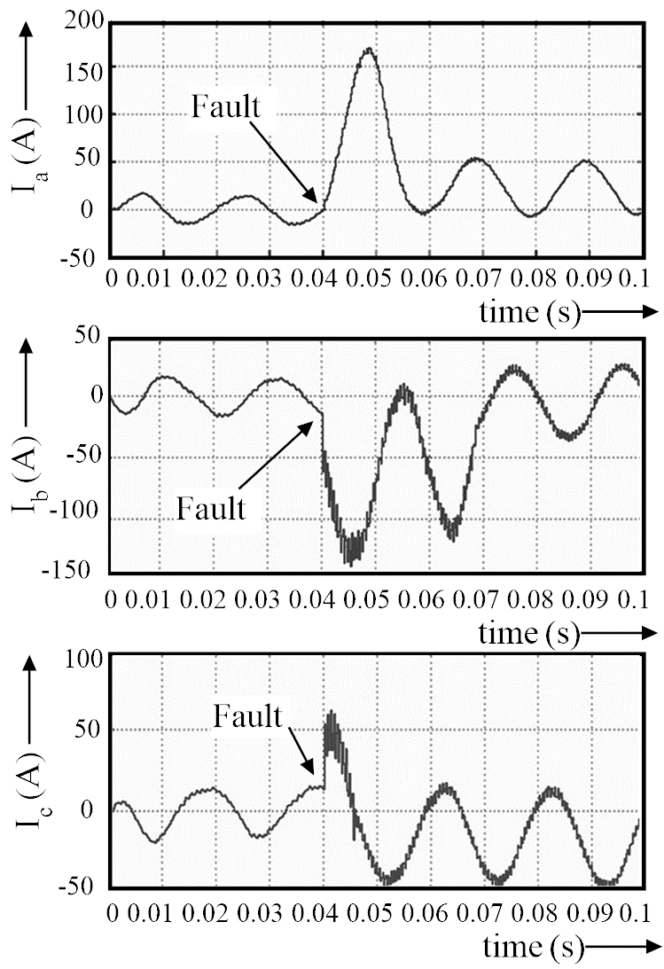

Fig. 7. Phase currents at bus bar A under fault in islanding mode.

* 1. *Case 4: Islanding Mode with Sequence Current Protection*

The system was simulated for different types of faults and sequence currents were analyzed. A mathematical model of the system was also developed and simulation results were verified. The positive, negative and zero sequence networks of the system are drawn. Symmetrical components of both voltage and current components were analyzed.

In case of a L-G fault the positive, negative and zero sequence equivalent circuits appear to be in series. In case of a L-L fault the equivalent sequence networks are in parallel and in case of a L-L-G ground fault all sequence networks appear to be in parallel if the fault impedance is low; otherwise the fault impedance will be in series with the negative sequence network. In order to verify the simulation results, a mathematical analysis is performed on the sequence networks and the results are found to be exactly in accordance with the simulation results.

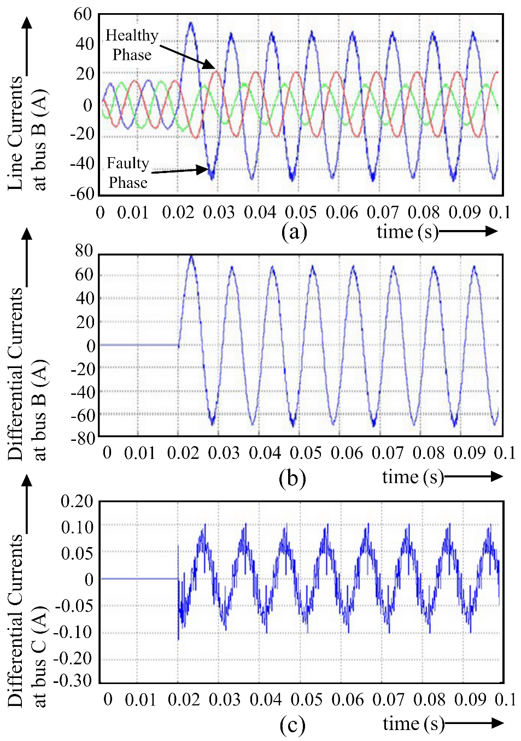

Fig. 8. L-G fault in zone B at t = 0.02 s (a) line currents at bus B, (b) differential current at bus B, and (c) differential current at bus C.

For a single L-G fault at bus B the positive, negative and zero sequence equivalent circuits appear to be in series connected at point B. The fault current can be calculated as:

$$I_{f}=3 I_{0}= 3 I_{1}= 3 I_{2}= \frac{V_{f}}{Z_{BB}^{1}+ Z_{BB}^{2}+Z_{BB}^{0}+3 Z_{f}}=22.5 A (2)$$

where I0, I1 and I2 are the symmetrical components of current, Zf is the fault impedance, Vf is the pre-fault bus voltage in p.u., $Z_{BB}^{1}$ is the element of positive sequence impedance matrix of the system at Bth row and Bth column, $Z_{BB}^{2}$ is the element of negative sequence impedance matrix of the system at Bth row and Bth column, and $Z_{BB}^{0}$ is the element of zero sequence impedance matrix of the system at Bth row and Bth column. Similarly for a L-L fault at bus B, positive and negative sequence networks appear to be in parallel and we have:

$$I_{1}= - I_{2}= \frac{V_{f}}{Z_{BB}^{1}+ Z_{BB}^{2}+ Z_{f}}=16 A (3)$$

Although the simulations were carried out for all types of faults on all system buses, the results discussed here are only for bus bar B faults. The bus bar B is the central bus in the system. The results derived for bus bar B are valid for the whole system. All types of faults were introduced on bus B with the microgrid in islanding mode. The results are summarized in Table II.

Under normal conditions negative-sequence and zero-sequence currents flowing in a system must be equal to zero for balanced loading. There will be some negative and zero sequence current in the system for unbalanced loading, but the magnitude of these currents will be very small as compared to the negative-sequence and zero-sequence currents flowing under faulty conditions. If there is a L-G fault in zone B, a zero-sequence current is detected at bas bar C. This zero-sequence current can be used to trigger the relay to isolate zone C by opening circuit breaker C. The same technique must be adopted for any upstream L-L-G fault detection. The downstream ground faults can easily be detected by the differential-current relay as discussed in the last section.

It is observed that L-L faults can be detected by measuring the negative-sequence component of current [11]. If there is a L-L fault, the magnitude of negative-sequence current increases. As shown in row 3 of Table II, a negative-sequence current is also detected at bus bar C, when there is a fault on bus bar B. It ensures that we do not need any special mechanism for the detection of L-L fault in the upstream zone. The negative-sequence current relay will protect against both upstream and downstream faults.

Symmetrical faults can not be detected by the sequence components, as they do not produce any sequence currents. Although the probability of having a symmetrical fault is very low but they are the worst type of faults and the system must be protected against these faults.

* 1. *Case 5: Voltage Based Protection*

The voltage-based protection can be used for protecting microgrids [7]. The voltage protection relays were activated, and the system was analysed for different normal and abnormal conditions. Different types of faults were introduced in zone B and the resulting voltage waveforms were analysed. The aim was to develop a protection scheme based on under voltages, especially for the detection of the symmetrical faults which are neither detected by the differential-current protection nor by the sequence components. It was found that the under-voltage protection can only provide limited protection. Moreover, the relays need to be time coordinated to have a selective operation. It is unusual for voltage based relays which are usually set to operate at a standard time.

Fig. 9 shows the voltages at bus bars B, C and A for a L-G fault on phase a in zone B. There is a voltage collapse in the faulty phase. The low voltage travels very quickly across the microgrid and a fault at bus bar B, produces low voltage at all the three system buses. If the under voltage relays are not properly coordinated, there will be a complete shutdown of the system for a fault at any protection zone.

# **Proposed Protection Scheme**

The fault detection must be based on the circuit currents and voltages measured at the same bus. It should not be dependent on any communication signal from the main centralized controller so that the peer-to-peer functionality of the system is not lost. It should be ensured that the protection scheme is reliable, selective and secure.

There are four protection devices in the microgrid under consideration. The proposed protection scheme for the microgrid is shown in Table III. The zero-sequence current detection is used for detecting ground faults. The pickup value of zero-sequence current is chosen to be 4 A. This value should not be very low, as the load imbalance can also cause zero-sequence currents. The negative-sequence current is used for the detection of L-L faults, as there will always be a considerable negative-sequence current whenever there is a L-L fault in the system for both upstream and downstream earth faults.

For the detection of symmetrical faults, under-voltage protection is used. The time of under-voltage relay is set to be three cycles which is a very small time for under-voltage protection.

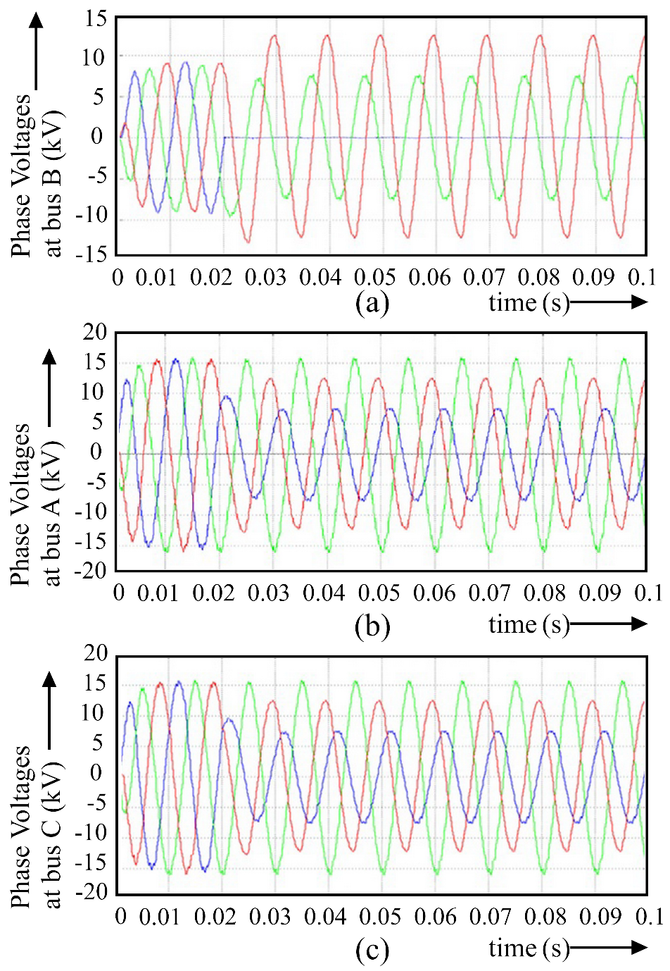

Fig. 9. L-G fault in zone B at t = 0.02 s (a) bus bar B voltages, (b) bus bar C voltages and (c) bus bar A voltages.

Thermal capacity or “I2t” relay is used as a back-up protection. Its value is set according to the thermal properties of the conductor and the critical system elements. A time delay setting of 3 cycles and pick up value of 250 A is used in all zones. In zone A, zone C and SS the main protection is faster than 3 cycles. The only zone where the main protection is slower than 3 cycles is zone B where the protection has to be time delayed to co-ordinate it with the protection in zone C. This faster backup protection in zone B will still not have any problem as it is set to operate at a very large value of current (250 A) as compared to the main protection. This protection will only operate if there is a fault in the grid connected mode and the SS fails to operate. A synchronism check relay is also installed to ensure that there is no loss of synchronism between the microgrid and the utility grid during reconnection.

The time delay for all the relays is set to be zero for the static switch. Time delays for relays A and C are set to be 40 ms (2 cycles @ 50 Hz): this is to ensure that the static switch operates before the circuit breakers A and C when a fault occurs. The time settings of relay in zone B is kept 120 milliseconds (6 cycles). There is an additional time delay of 4 cycles in unsymmetrical fault protection. It is to ensure that the zone C is isolated before the tripping of circuit breaker B in case of a fault in zone C.

An additional time delay of 3 cycles is introduced in under-voltage protection to allow isolation of zone C before the tripping of circuit breaker B in case of a symmetrical fault in zone C.

The above protection scheme is implemented and the circuit is simulated for different fault conditions. A few selected results are shown here.

* 1. *L-G Fault in Zone B*

The current waveforms at bus bars B and C for a L-G fault in zone B is shown in Fig. 10. The trip signals generated by relays installed in zone B and C are also shown. The fault is introduced at t = 0.06 seconds. When the fault is introduced a trip signal is generated by the differential-current relay at zone B after a time interval of 120 ms. Trip signal is also generated by the sequence relay installed at zone C. This trip signal is generated after a time interval of 40 ms. Hence, both circuit breakers B and C are tripped and the faulty section is isolated.

* 1. *L-L Fault in Zone B*

The trip signals generated by relays installed in zone B and C are shown in Fig. 11 (a). The fault is introduced at t = 0.06 seconds. Trip is generated by the sequence relays installed at zone B and zone C after 120 ms and 40 ms respectively.

* 1. *Symmetrical Fault in Zone B*

The trip signals generated by relays installed in zone B and C are shown in Fig. 11 (b). The fault is introduced at t = 0.06 seconds. Trip is generated by the under-voltage relays installed at zone B and zone C after 120 ms and 60 ms respectively.

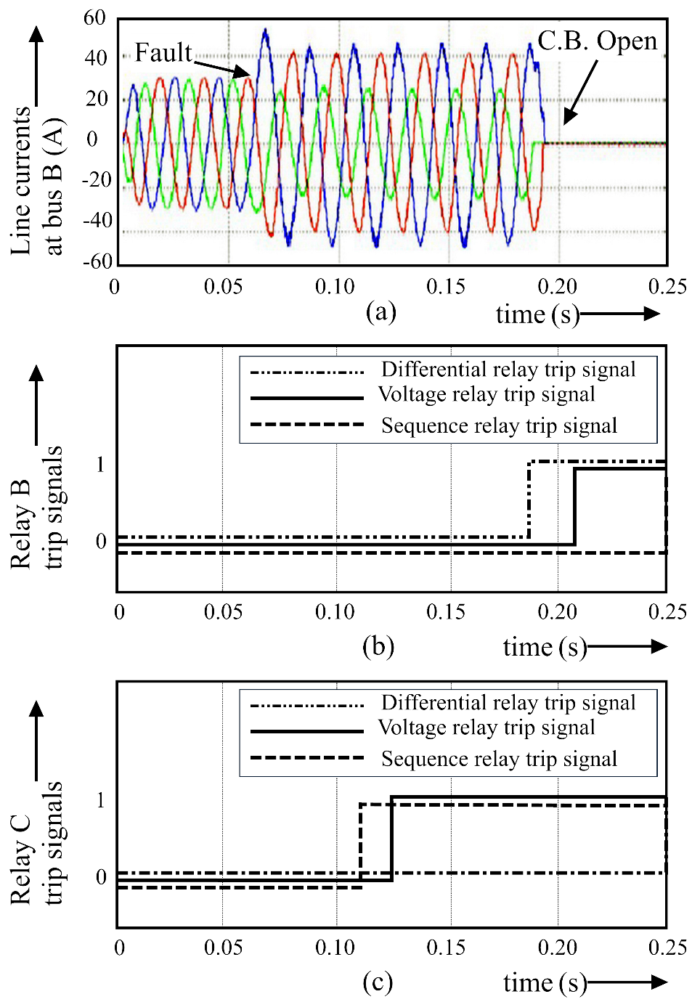

Fig. 10. L-G Fault in zone B at t = 0.06 s (a) bus B line currents, (b) relay B trip signals and (c) relay C trip signals.

# **Discussion**

A protection scheme has been proposed which is a combination of time graded differential current, sequence current, and under-voltage protection. It is demonstrated how primary and secondary protection can be achieved, both in grid-connected and islanding modes. A thermal capacity relay is used as a backup protection. The proposed protection scheme overcomes the problem of security such as false trips encountered in references [12]-[13], and inability to detect upstream faults in reference [11]. It does not require any communication, unlike in references [8]- [10], so the plug and play functionality is not compromised. However, the sequence components have to be chosen carefully to avoid false tripping in the case of extreme imbalance. Also, the relay time settings will have to be modified if additional feeders/lines are added in the microgrid.

# **Conclusion**

Differential current protection is a good way to detect the downstream ground faults but it has limited applications as it is not capable of isolating the upstream faulty sections. This is a major problem for radial microgrids with a large number of distributed generation units.

The sequence components of currents can be used to design fault detection techniques which are not based on current magnitude. There must be a sufficient margin between the relay pick-up values and the normal sequence components caused by the load imbalance. There is a considerable zero-sequence current flowing in case of a L-G fault which can be used for isolation. The L-L faults can be detected by negative-sequence currents for both upstream and downstream faults. The proposed protection scheme is secure and selective. It does not require any communication between the protection devices.

Symmetrical faults can not be detected by the sequence components as only positive-sequence currents are produced by the symmetrical faults. Although the probability of having a symmetrical fault is very low but they are the worst type of faults. Symmetrical faults can be detected by using under-voltage relaying. This under-voltage protection must be time graded to avoid complete shutdown of the microgrid in case of a fault.

Efficient time co-ordination can be provided between all relays to have selectivity. The combination of protection schemes mentioned above, with introduction of co-ordination time delays can be used to protect a microgrid in islanding mode.

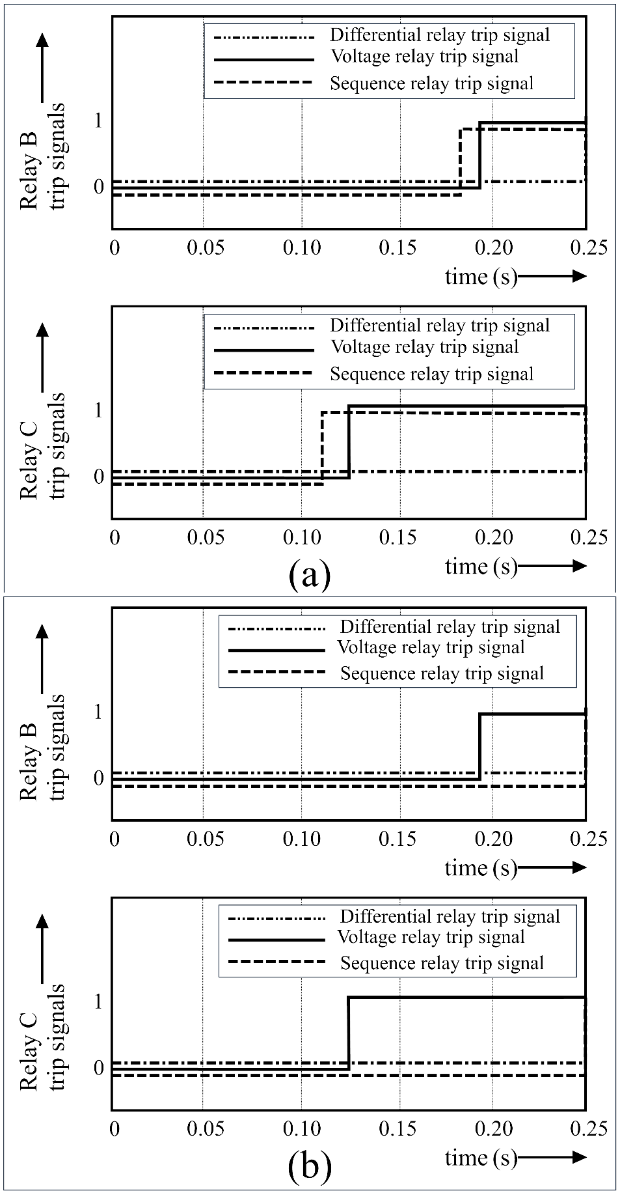

Fig.11. (a) Relay B and C trip signals for a L-L fault at bus B at t = 0.006 s (b) Relay B and C trip signals for a symmetrical fault at bus B at t = 0.006 s.

TABLE I: Relay Settings for Grid Connected Mode.

|  |  |  |  |  |  |
| --- | --- | --- | --- | --- | --- |
| Bus | Load current | Fault current for 3-phase fault at the bus in Grid Connected Mode | Fault current for 3-phase fault at the bus in Islanding Connected Mode | Relay setting | Co-ordination time delay |
| *A* | 10 A | 7778 A | 22.1 A | 150 A | 0 ms |
| *B* | 19.8 A | 7778 A | 22.1 A | 150 A | 20 ms (1 cycle) |
| *C* | 9.89 A | 7690 A | 21 A | 150 A | 0 ms |
| *D* | 950 A | 7800 A | - | 3000 A | 0 ms |
| *Grid* | 990 A | 10000 A | - | 3200 A | 40 ms (2 cycles) |

TABLE II: Sequence Components of Currents for Fault on Bus B.

|  |  |  |  |
| --- | --- | --- | --- |
| Type of fault | Sequence components of current at bus B | Sequence components of current at bus C | Sequence components of current at bus A |
| *L-G* | I1 = 22.0 A  I2 = 8.8 A  I0 = 7.50 A | I1 = 11.0 A  I2 = 4.40 A  I0 = 7.50 A | I1 = 11.0 A  I2 = 4.40 A  I0 = 7.50 A |
| *L-L-G* | I1 = 12.4 A  I2 = 12.4 A  I0 = 6.10 A | I1 = 6.20 A  I2 = 6.20 A  I0 = 6.10 A | I1 = 6.20 A  I2 = 6.20 A  I0 = 6.10 A |
| *L-L* | I1 = 16.0 A  I2 = 16.0 A  I0 = 0.00 A | I1 = 8.00 A  I2 = 8.00 A  I0 = 0.00 A | I1 = 8.00 A  I2 = 8.00 A  I0 = 0.00 A |
| *L-L-L /*  *L-L-L-G* | I1 = 64.0 A  I2 = 0.00 A  I0 = 0.00 A | I1 = 14.0 A  I2 = 0.00 A  I0 = 0.00 A | I1 = 14.0 A  I2 = 0.00 A  I0 = 0.00 A |

TABLE III: Protection Scheme for the Microgrid.

|  |  |  |  |  |
| --- | --- | --- | --- | --- |
| Relay | Function | Purpose | Trip setting | Time setting |
| *SS* | Under voltage | Symmetrical fault protection | 50 % of rated voltage | 3 cycles (60 ms) |
| Differential current | Downstream earth fault protection | Id > 10 A | 0 ms |
| Zero sequence current | Upstream earth fault protection | |Io| > 4 A | 0 ms |
| Negative sequence current | L-L fault protection | |I2 | > 6 A | 0 ms |
| Thermal capacity relay | Backup protection | 500 A | 3 cycles (60 ms) |
| *A* | Under voltage | Symmetrical fault protection | 50 % of rated voltage | 3 cycles (60 ms) |
| Differential current | Downstream earth fault protection | Id > 10 A | 2 cycles (40 ms) |
| Zero sequence current | Upstream earth fault protection | |Io| > 4 A | 2 cycles (40 ms) |
| Negative sequence current | L-L fault protection | |I2 | > 6 A | 2 cycles (40 ms) |
| Thermal capacity relay | Backup protection | 250 A | 3 cycles (60 ms) |
| *B* | Under voltage | Symmetrical fault protection | 50 % of rated voltage | 6 cycles (120 ms) |
| Differential current | Downstream earth fault protection | Id > 10 A | 6 cycles (120 ms) |
| Zero sequence current | Upstream earth fault protection | |Io| > 4 A | 6 cycles (120 ms) |
| Negative sequence current | L-L fault protection | |I2 | > 6 A | 6 cycles (120 ms) |
| Thermal capacity relay | Backup protection | 250 A | 3 cycles (60 ms) |
| *C* | Under voltage | Symmetrical fault protection | 50 % of rated voltage | 3 cycles (60 ms) |
| Differential current | Downstream earth fault protection | Id > 10 A | 2 cycles (40 ms) |
| Zero sequence current | Upstream earth fault protection | |Io| > 4 A | 2 cycles (40 ms) |
| Negative sequence current | L-L fault protection | |I2 | > 6 A | 2 cycles (40 ms) |
| Thermal capacity relay | Backup protection | 250 A | 3 cycles (60 ms) |

# **References**

[1] G. M. Masters, *Renewable and Efficient Electric Power Systems*. John Wiley & Sons, Inc, 2004.

[2] E. J. Coster, J. M. A. Myrzik, B. Kruimer, and W. L. Kling, “Integration Issues of Distributed Generation in Distribution Grids,” *Proceedings of the IEEE*, vol. 99, no. 1. pp. 28–39, 2011.

[3] A. Papavasiliou and S. S. Oren, “Large-Scale integration of deferrable demand and renewable energy sources,” *IEEE Trans. Power Syst.*, vol. 29, no. 1, pp. 489–499, 2014.

[4] R. H. Lasseter and P. Paigi, “Microgrid : A Conceptual Solution,” pp. 4285–4290, 2004.

[5] R. H. Lasseter, “Smart distribution: Coupled microgrids,” *Proc. IEEE*, vol. 99, no. 6, pp. 1074–1082, 2011.

[6] M. A. Zamani, T. S. Sidhu, and A. Yazdani, “Investigations Into the Control and Protection of an Existing Distribution Network to Operate as a Microgrid: A Case Study,” *IEEE Transactions on Industrial Electronics*, vol. 61, no. 4. pp. 1904–1915, 2014.

[7] S. Parhizi, H. Lotfi, A. Khodaei, and S. Bahramirad, “State of the Art in Research on Microgrids: A Review,” *IEEE Access*, vol. 3. pp. 890–925, 2015.

[8] T. S. Ustun and R. H. Khan, “Multiterminal Hybrid Protection of Microgrids Over Wireless Communications Network,” *IEEE Transactions on Smart Grid*, vol. 6, no. 5. pp. 2493–2500, 2015.

[9] T. S. Ustun, C. Ozansoy, and A. Ustun, “Fault current coefficient and time delay assignment for microgrid protection system with central protection unit,” *IEEE Transactions on Power Systems*, vol. 28, no. 2. pp. 598–606, 2013.

[10] C. Yuan, M. A. Haj-ahmed, and M. S. Illindala, “Protection Strategies for Medium-Voltage Direct-Current Microgrid at a Remote Area Mine Site,” *IEEE Transactions on Industry Applications*, vol. 51, no. 4. pp. 2846–2853, 2015.

[11] S. Kar and S. R. Samantaray, “Time-frequency transform-based differential scheme for microgrid protection,” *IET Generation, Transmission & Distribution*, vol. 8, no. 2. pp. 310–320, 2014.

[12] W. K. A. Najy, H. H. Zeineldin, and W. L. Woon, “Optimal Protection Coordination for Microgrids With Grid-Connected and Islanded Capability,” *IEEE Transactions on Industrial Electronics*, vol. 60, no. 4. pp. 1668–1677, 2013.

[13] A. H. Etemadi and R. Iravani, “Overcurrent and Overload Protection of Directly Voltage-Controlled Distributed Resources in a Microgrid,” *IEEE Transactions on Industrial Electronics*, vol. 60, no. 12. pp. 5629–5638, 2013.

[14] E. Casagrande, W. L. Woon, H. H. Zeineldin, and D. Svetinovic, “A Differential Sequence Component Protection Scheme for Microgrids With Inverter-Based Distributed Generators,” *IEEE Transactions on Smart Grid*, vol. 5, no. 1. pp. 29–37, 2014.

[15] H. Laaksonen and K. Kauhaniemi, “Smart protection concept for LV microgrid,” *Int. Rev. Electr. Eng.*, vol. 5, no. 2, pp. 578–592, 2010.

# **Authors Biographies**



*Zohaib Akhtar* received the B.Sc. (Hons.) and M.Sc. degrees in electrical engineering from the University of Engineering and Technology, Lahore, Pakistan, in 2008 and 2011, respectively. He joined the Department of Electrical Engineering, University of Engineering & Technology, Lahore, Pakistan as a Lecturer in 2008 and became an Assistant Professor in 2012. He is currently pursuing his Ph.D. degree from Imperial College London, U.K. His current research interests include renewable energy, power distribution and smart grids.



*Muhammad Asghar Saqib* graduated in electrical (power) engineering from the Department of Electrical Engineering at the University of Engineering and Technology, Lahore (Pakistan), in 1991. As AusAID scholar he completed his Master’s and PhD studies in electrical (power) engineering from University of Sydney, Australia, in 1996 and 1999 respectively. He then joined the Faculty of Electronics Engineering at GIK Institute, Topi (Pakistan), as Assistant Professor and became Associate Professor and Dean of the Faculty in 2005. Since 31 December 2005 he has been working as Associate Professor in the Department of Electrical Engineering at University of Engineering and Technology, Lahore. He research interests are in the areas of power electronics and electrical drives, high voltage engineering, renewable energy and power system protection. He is the Director of High Voltage Engineering Laboratory in the Department of Electrical Engineering.